5CS024
Collaborative Development

Software Requirements Specification

Business Analyst: Rupika Dangol
Group: L5CG8
Student ID: 2461999
Module: Collaborative Development
Project: Vehicle Rental System
Tutor: Anish Maharjan
Date: 31 March 2026
Table of Contents
1. Functional Decomposition Diagram 1
2. Software Requirements Specification Subsystems 2
2.1 Subsystem 1: Account & Security (AS) 2
2.2 Subsystem 2: Vehicle Catalog & Search (VC) 3
2.3 Subsystem 3: Booking & Payment (BP) 4
2.4 Subsystem 4: Customer Dashboard (CD) 6
2.5 Subsystem 5: Admin Fleet Management (AF) 7
2.6 Subsystem 6: Admin Booking Operations (AO) 8
2.7 Subsystem 7: Live Telemetry & Tracking (LT) 9
3. Vehicle Booking Process Activity Diagram 10
4. Admin Flow Activity Diagram 11
5. Use Case Diagram 12
6. Data Dictionary 13
6.1 User Entity (users table) 13
6.2 Category Entity (categories table) 14
6.3 Vehicle/Fleet Entity (vehicles table) 15
6.4 Booking Entity (bookings table) 16
6.5 Payment Entity (payments table) 17
6.6 Maintenance Entity (maintenance_records table) 18
6.7 GPS Telemetry Entity (gps_logs table) 19
7. Class Diagram 20
8. Sequence Diagram 21

List of Figures
Fig 1: Functional Decomposition Diagram 1
Fig 2.1: UML Activity Diagram for User & Admin Authentication Flow (Subsystem 1) 2
Fig 2.2: UML Activity Diagram for Booking/Filtering & Detailed description (Subsystem 2) 3
Fig 2.3: UML Activity Diagram for Khalti Payment Process (Subsystem 3) 5
Fig 2.4: UML Activity Diagram for Khalti My Bookings Section (Subsystem 4) 6
Fig 2.5: UML Activity Diagram for Admin Manage Fleet (Subsystem 5) 7
Fig 26: UML Activity Diagram for Admin “All Bookings” (Subsystem 6) 8
Fig 2.7: UML Activity Diagram for Admin Live Telemetry & Tracking (Subsystem 7) 9
Fig 3: UML Activity Diagram for the Vehicle Booking and Reservation Process. 10
Fig 4: UML Activity Diagram for basic Admin Flow 11
Fig 5: Use Case Diagram 12
Fig 7: Class Diagram 20
Fig 8: Sequence Diagram 21

List of Tables
Table 2.1: Subsystem 1: Account & Security Management (AS) 2
Table 2.2: Subsystem 2: Vehicle Catalog & Search (VC) 3
Table 2.3: Subsystem 3: Booking & Payment (BP) 4
Table 2.4: Subsystem 4: Customer Dashboard (CD) 6
Table 2.5: Subsystem 5: Admin Fleet Management (AF) 7
Table 2.6: Subsystem 6: Admin Booking Operations (AO) 8
Table 2.7: Subsystem 7: Live Telemetry & Tracking (LT) 9
Table 6.1: User Entity (users table) 13
Table 6.2: Category Entity (categories table) 14
Table 6.3: Vehicle/Fleet Entity (vehicles table) 15
Table 6.4: Booking Entity (bookings table) 16
Table 6.5: Payment Entity (payments table) 17
Table 6.6: Maintenance Entity (maintenance_records table) 18
Table 6.7: GPS Telemetry Entity (gps_logs table) 19

Functional Decomposition Diagram
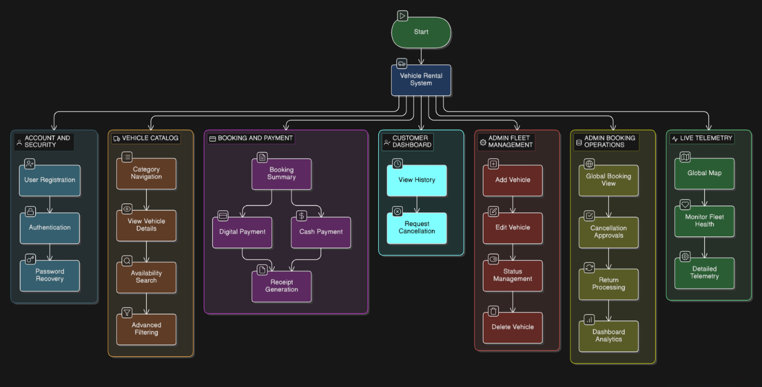

Fig 1: Functional Decomposition Diagram

Software Requirements Specification Subsystems

Subsystem 1: Account & Security (AS)
Req. Code | Req. Description | Use Case
AS-F-1.0 | The system shall allow users to register with name, email, phone, and drivers ID. | Create Account
AS-F-1.1 | The system shall process secure login for both Customers and Admins. | Login
AS-NF-1.1 | All passwords must be encrypted using Bcrypt hashing before storage in the database. | Security
AS-UR-1.1 | The login form shall provide clear error messages for "Incorrect Password" vs ""User Not Found." | Login

Table 2.1: Subsystem 1: Account & Security Management (AS)

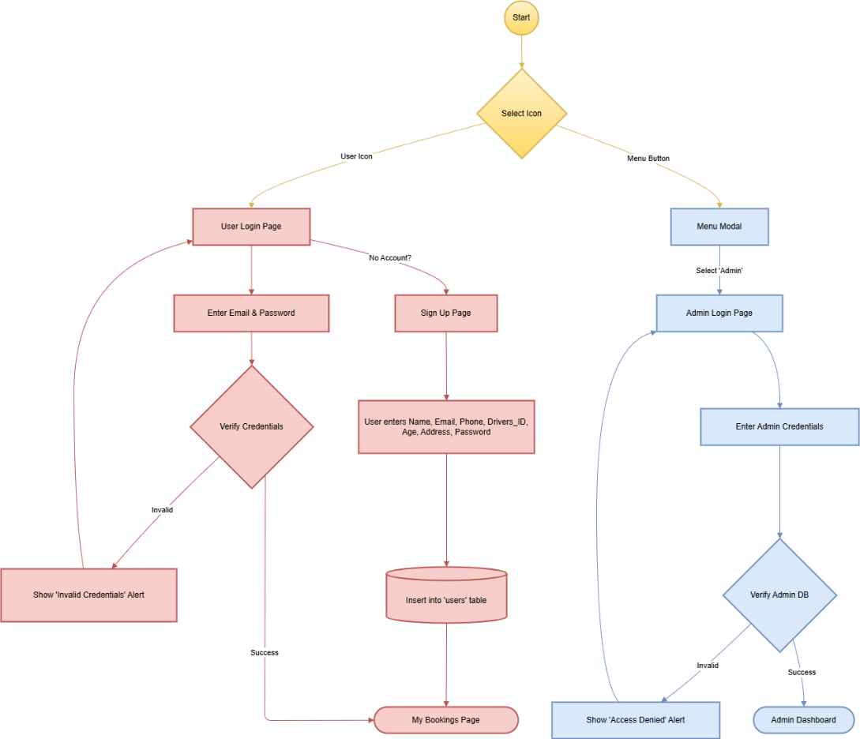

Fig 2.1: UML Activity Diagram for User & Admin Authentication Flow (Subsystem 1)

Subsystem 2: Vehicle Catalog & Search (VC)
Req. Code | Req. Description | Use Case
VC-F-2.0 | The system shall filter vehicles by category (Bike, Car, Luxury) and date availability. | Search Available Vehicle
VC-F-2.1 | The system shall display detailed vehicle specs including fuel type, transmission, and pricing. | View Details
VC-NF-2.1 | Vehicle search results must populate within 2 seconds of the user clicking ""Search."" | Performance
VC-UR-2.1 | Search filters must remain sticky or easily accessible as the user scrolls through listings. | User Experience

Table 2.2: Subsystem 2: Vehicle Catalog & Search (VC)
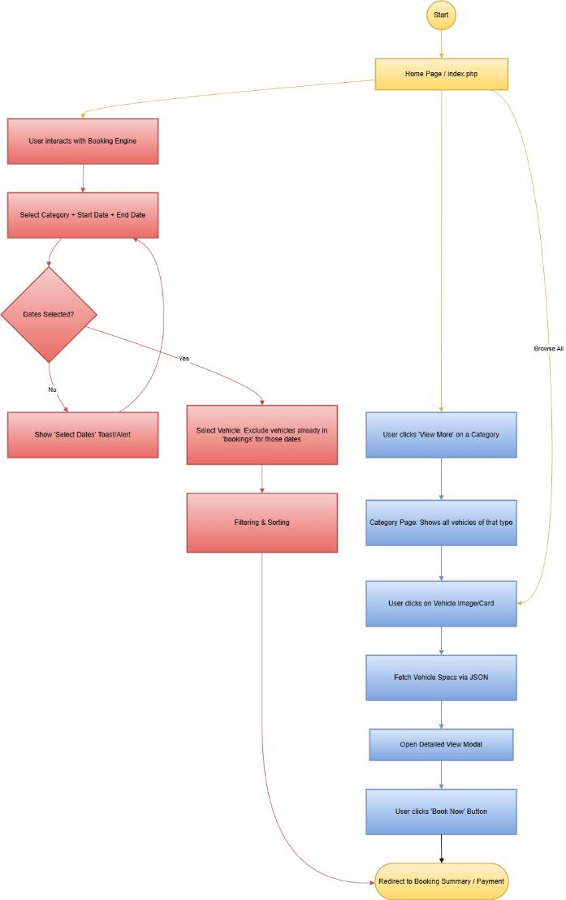

Fig 2.2: UML Activity Diagram for Booking/Filtering & Detailed description (Subsystem 2)

Subsystem 3: Booking & Payment (BP)
Req. Code | Req. Description | Use Case
BP-F-3.0 | The system shall integrate Khalti API for digital payments including OTP verification. | Process Payment
BP-F-3.1 | The system shall generate a unique PNG receipt (e.g., #RX-8821) upon successful booking. | Generate Receipt
BP-NF-3.1 | Payment processing must be handled over a secure HTTPS connection to protect financial data. | Security
BP-UR-3.1 | The booking summary must clearly show the breakdown of base price, taxes, and total cost. | Transparency

Table 2.3: Subsystem 3: Booking & Payment (BP)

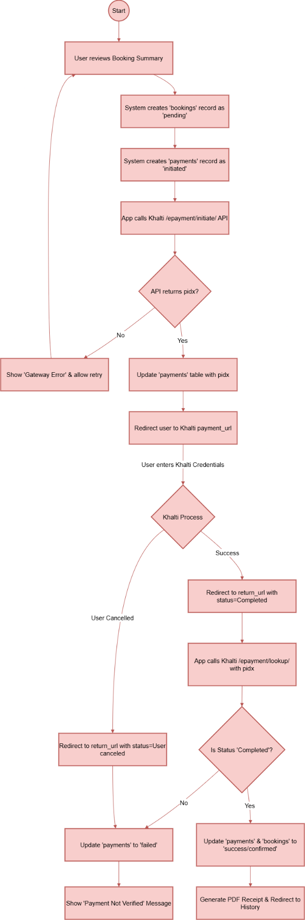

Fig 2.3: UML Activity Diagram for Khalti Payment Process (Subsystem 3)

Subsystem 4: Customer Dashboard (CD)
Req. Code | Req. Description | Use Case
CD-F-4.0 | The system shall categorize bookings into "Active," "Pending," and "Completed" tabs. | View History
CD-F-4.1 | The system shall allow users to request a cancellation if the booking is still "Pending." | Cancel Booking
CD-NF-4.1 | The history table must be responsive and legible on mobile screen sizes. | Compatibility
CD-UR-4.1 | Navigation between booking tabs must be instantaneous using AJAX to avoid page refreshes. | Fluidity

Table 2.4: Subsystem 4: Customer Dashboard (CD)

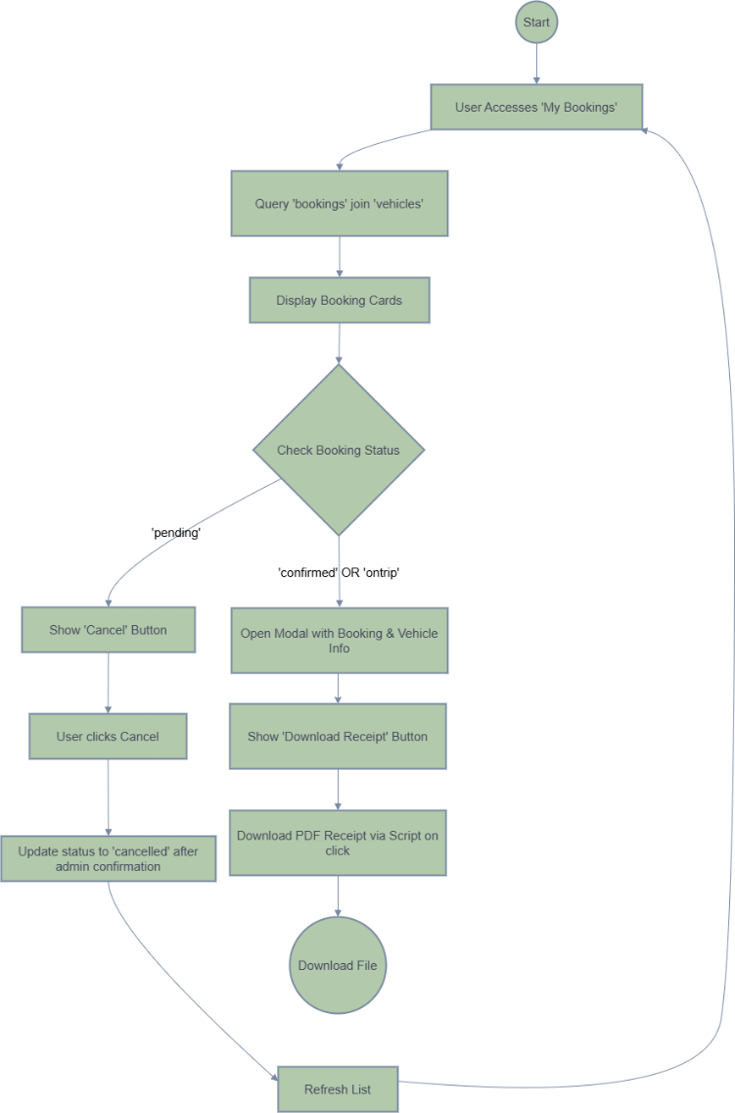

Fig 2.4: UML Activity Diagram for Khalti My Bookings Section (Subsystem 4)

Subsystem 5: Admin Fleet Management (AF)
Req. Code | Req. Description | Use Case
AF-F-5.0 | The admin shall be able to Add, Edit, and Delete vehicle records from the MySQL database. | Manage Fleet
AF-F-5.1 | The admin shall toggle vehicle status from "Available," to "Maintenance." | Update Status
AF-NF-5.1 | All vehicle image uploads must be restricted to .jpg and .png formats with a 5MB limit. | Data Integrity
AF-UR-5.1 | The system must require a double-confirmation modal before a vehicle is permanently deleted. | Action Forgiveness

Table 2.5: Subsystem 5: Admin Fleet Management (AF)

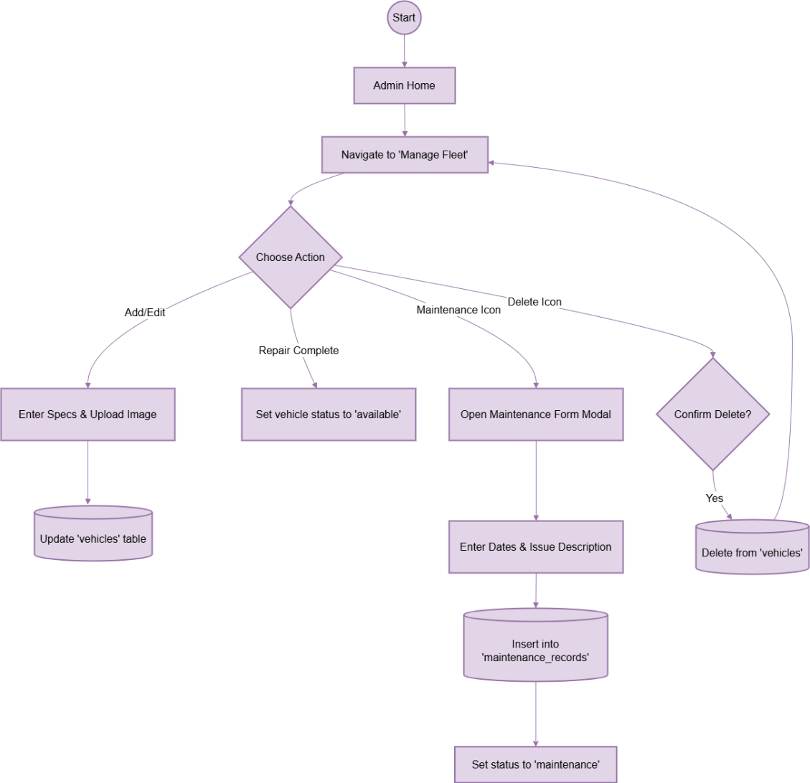

Fig 2.5: UML Activity Diagram for Admin Manage Fleet (Subsystem 5)

Subsystem 6: Admin Booking Operations (AO)
Req. Code | Req. Description | Use Case
AO-F-6.0 | The system shall automatically calculate late fees ($10/h) during the return process. | Process Return
AO-F-6.1 | The admin dashboard shall display revenue charts and fleet availability graphs via Chart.js. | View Analytics
AO-NF-6.1 | The dashboard metrics must refresh automatically every minute. | Freshness
AO-UR-6.1 | KPI cards (e.g., Fuel Warning) must use high-contrast colors (Red/Yellow) for quick scanning. | Scannability

Table 2.6: Subsystem 6: Admin Booking Operations (AO)
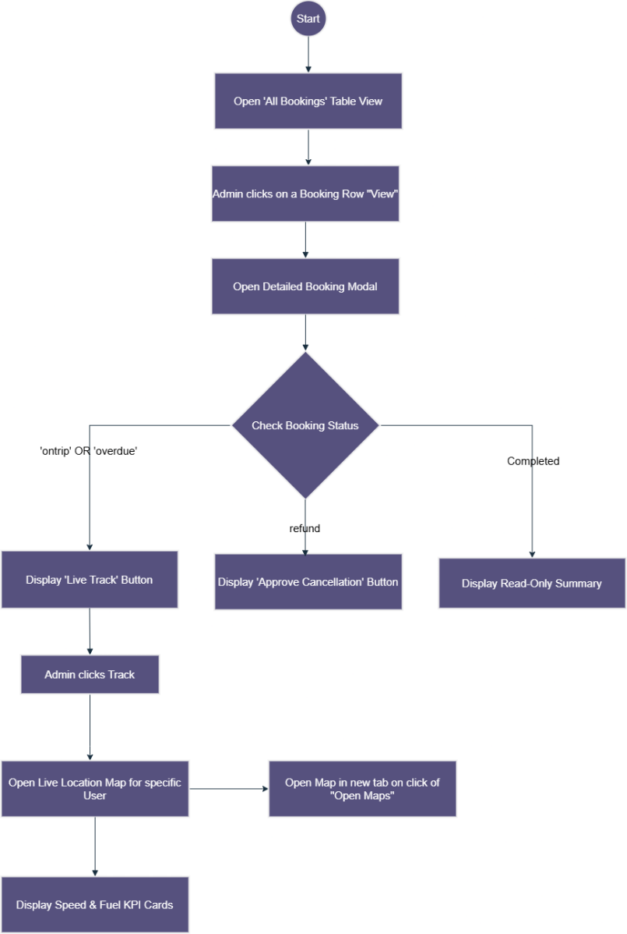

Fig 26: UML Activity Diagram for Admin “All Bookings” (Subsystem 6)

Subsystem 7: Live Telemetry & Tracking (LT)
Req. Code | Req. Description | Use Case
LT-F-7.0 | The system shall plot active vehicles on a map with real-time coordinate updates from the DB. | Live Tracking
LT-F-7.1 | The system shall calculate an AI Safety Score based on speed and braking telemetry. | Monitor Safety
LT-NF-7.1 | GPS coordinates must be stored as Decimal (9,6) in SQL for high geographical precision. | Accuracy
LT-UR-7.1 | Clicking a location icon must open the precise location in an external Google Maps tab. | Interaction

Table 2.7: Subsystem 7: Live Telemetry & Tracking (LT)
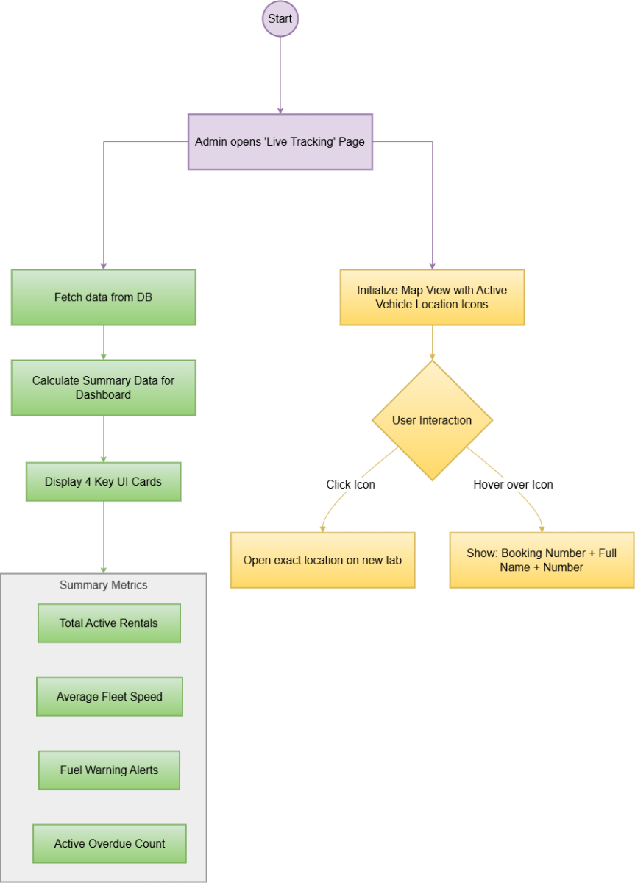

Fig 2.7: UML Activity Diagram for Admin Live Telemetry & Tracking (Subsystem 7)

Vehicle Booking Process Activity Diagram
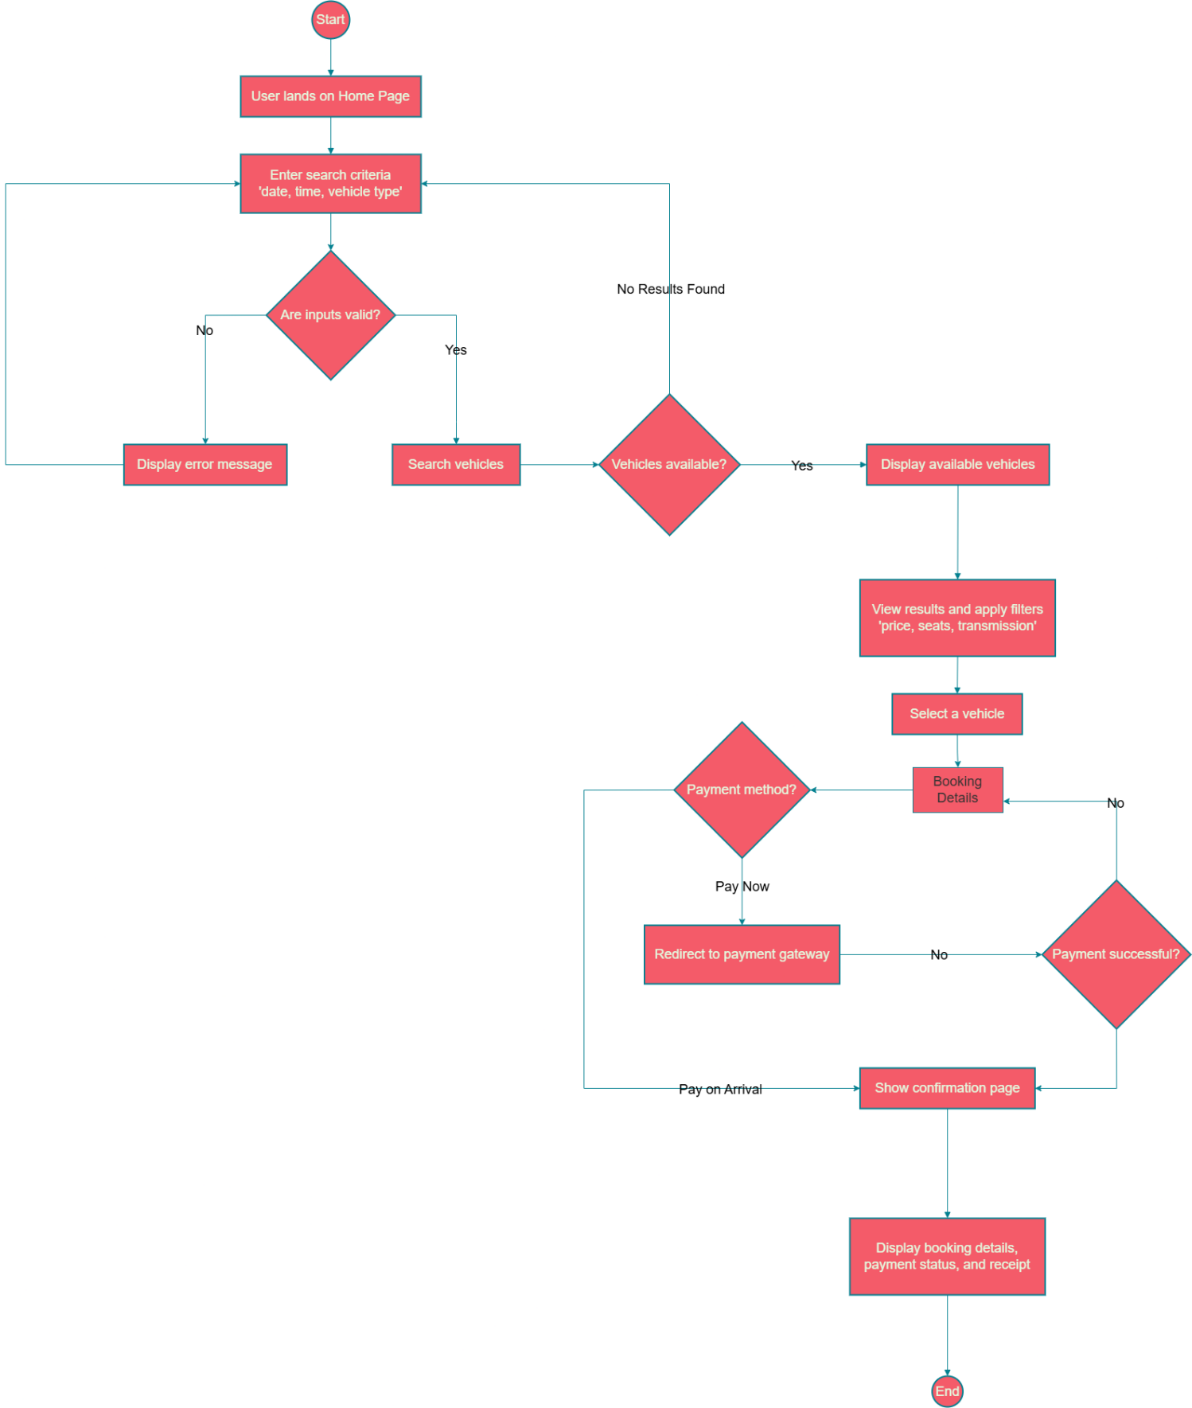

Fig 3: UML Activity Diagram for the Vehicle Booking and Reservation Process.

Admin Flow Activity Diagram
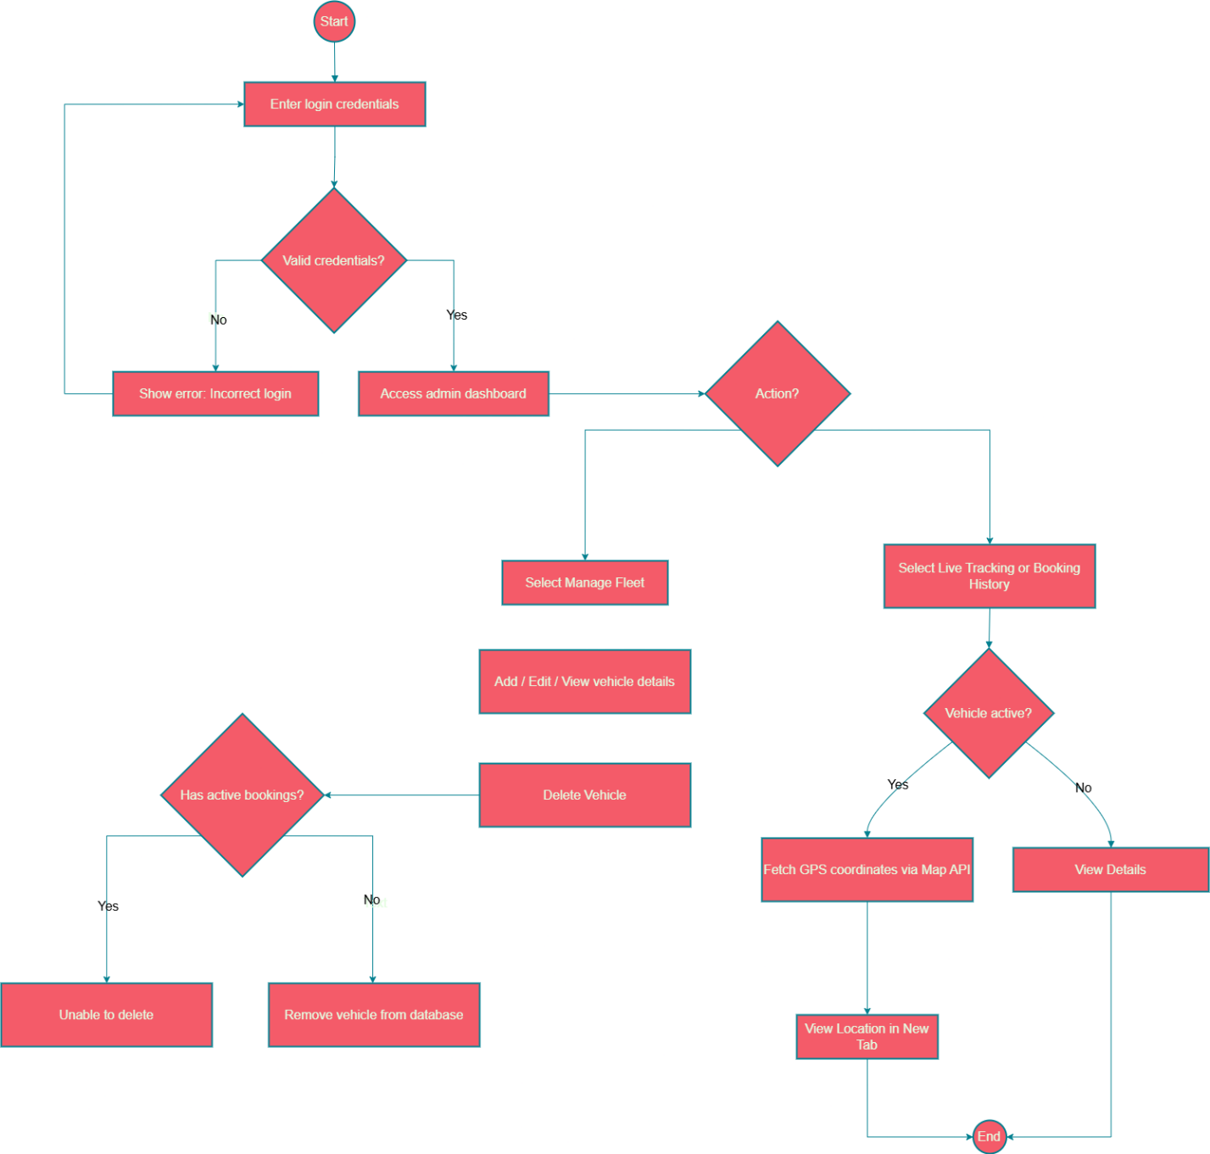

Fig 4: UML Activity Diagram for basic Admin Flow

Use Case Diagram
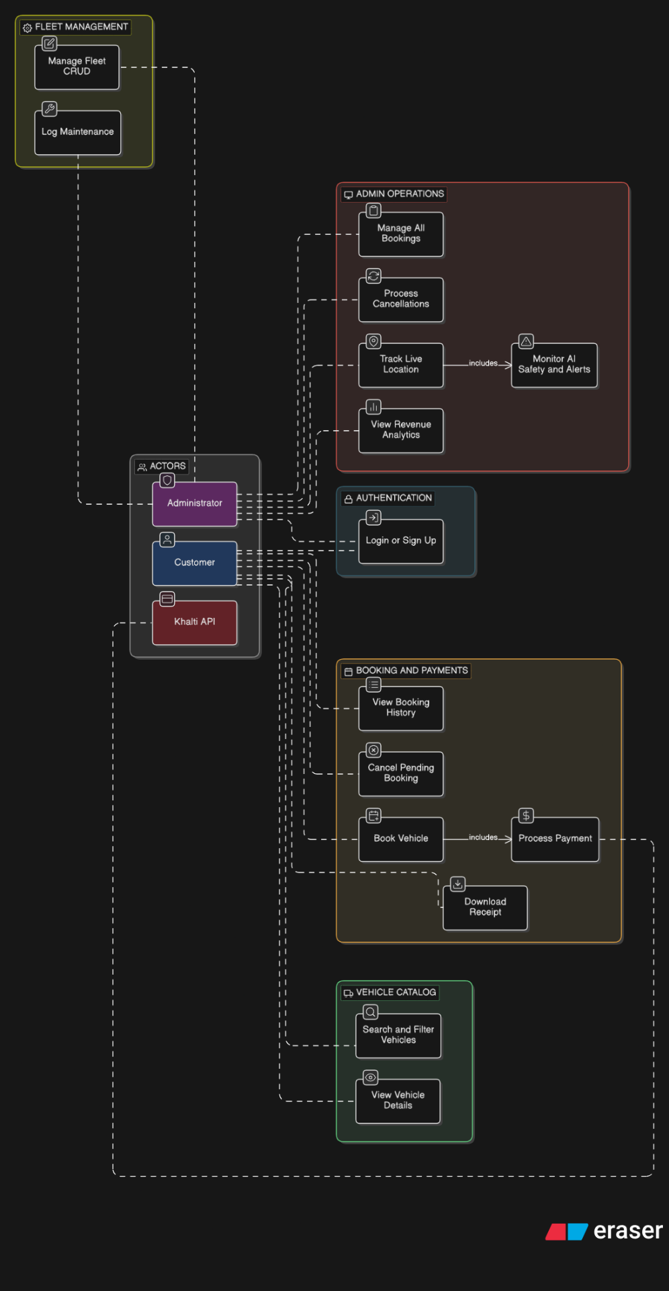

Fig 5: Use Case Diagram

Data Dictionary

6.1 User Entity (users table)
Name | Description/Definition | Alias | Data Type | Size | Constraints / Rules | Source
id | Unique identifier for the registered user. | User ID | INT | 11 | Primary Key, Auto-increment | System
name | The complete legal name of the user. | Full Name | VARCHAR | 100 | NOT NULL | User Input
email | User's email address used for login. | - | VARCHAR | 150 | UNIQUE, NOT NULL | User Input
password_hash | Bcrypt encrypted password string. | Pass | VARCHAR | 255 | NOT NULL | System
phone | Contact telephone number. | - | VARCHAR | 20 | Optional | User Input
address | Full physical address of the user. | - | VARCHAR | 255 | Optional | User Input
role | Defines the access level of the user. | User Type | ENUM | - | 'user', 'admin' (Default: 'user') | System
drivers_id | Government issued driver's license number. | License | VARCHAR | 50 | Optional for admins | User Input

Table 6.1: User Entity (users table)

6.2 Category Entity (categories table)
Name | Description/Definition | Alias | Data Type | Size | Constraints / Rules | Source
id | Unique identifier for the vehicle category. | Cat ID | INT | 11 | Primary Key, Auto-increment | System
name | Name of the classification (e.g., Car, Bike, Luxury). | Type | VARCHAR | 50 | UNIQUE, NOT NULL | Admin
description | Brief explanation of the category. | - | TEXT | - | Optional | Admin

Table 6.2: Category Entity (categories table)

6.3 Vehicle/Fleet Entity (vehicles table)
Name | Description/Definition | Alias | Data Type | Size | Constraints / Rules | Source
id | Unique identifier for the vehicle. | Bike/Car ID | INT | 11 | Primary Key, Auto-increment | System
category_id | Links vehicle to its classification. | Cat ID | INT | 11 | Foreign Key (categories.id) | Admin
short_name | Make/model used in UI cards. | Name | VARCHAR | 100 | NOT NULL | Admin
full_name | Complete make/model for details page. | - | VARCHAR | 150 | NOT NULL | Admin
price_per_day | Daily rental cost (stored as integer). | Rate | INT | 11 | NOT NULL, > 0 | Admin
driver_age_requirement | Minimum age (e.g., 18 or 21). | Age Req | INT | 2 | NOT NULL | Admin
transmission_type | Manual, Automatic, or Hybrid. | Trans | ENUM | - | 'manual', 'automatic', 'hybrid' | Admin
fuel_type | Petrol, Diesel, or Electric. | Fuel | ENUM | - | 'petrol', 'diesel', 'electric' | Admin
license_plate | Unique government registration plate. | Plate No | VARCHAR | 50 | UNIQUE, NOT NULL | Admin
status | Current physical and booking availability. | State | ENUM | - | 'available', 'reserved', 'ready', 'on_trip', 'overdue', 'maintenance' | System/Admin
gps_id | Hardware ID linking to the IoT tracker. | Tracker ID | VARCHAR | 50 | Optional | Admin
last_service_date | Date of the most recent maintenance. | Service Dt | DATE | - | Format: YYYY-MM-DD | Admin

Table 6.3: Vehicle/Fleet Entity (vehicles table)

6.4 Booking Entity (bookings table)
Name | Description/Definition | Alias | Data Type | Size | Constraints / Rules | Source
id | Unique internal identifier for the rental. | Order ID | INT | 11 | Primary Key, Auto-increment | System
booking_number | Public UI identifier (Format: #XX-0000). | Booking No | VARCHAR | 15 | UNIQUE, NOT NULL | System
user_id | The customer who made the booking. | Client ID | INT | 11 | Foreign Key (users.id) | System
vehicle_id | The specific vehicle being rented. | Fleet ID | INT | 11 | Foreign Key (vehicles.id) | System
pickup_datetime | Scheduled start of the rental. | Start Date | DATETIME | - | NOT NULL | User
return_datetime | Scheduled end of the rental. | End Date | DATETIME | - | NOT NULL | User
return_time | Actual time the vehicle was brought back. | Actual Ret | DATETIME | - | NULL allowed until returned | Admin
status | The vehicle's lifecycle state for this booking. | Trip State | ENUM | - | 'pending', 'reserved', 'ready', 'on_trip', 'overdue', 'completed', 'cancelled' | System/Admin
payment_status | Current state of the customer's bill. | Bill State | ENUM | - | 'unpaid', 'pending', 'paid', 'cancelled', 'refunded' | System
payment_method | Chosen gateway (Khalti vs Cash). | Pay Type | ENUM | - | 'pay_on_arrival', 'khalti' | User
total_amount | Total calculated cost (stored as integer). | Total | INT | 11 | NOT NULL | System
late_fee | Penalties calculated upon return ($10/hr). | Fines | INT | 11 | Default 0 | System

Table 6.4: Booking Entity (bookings table)

6.5 Payment Entity (payments table)
Name | Description/Definition | Alias | Data Type | Size | Constraints / Rules | Source
id | Unique identifier for the transaction. | Txn ID | INT | 11 | Primary Key, Auto-increment | System
booking_id | The rental order this transaction covers. | Order ID | INT | 11 | Foreign Key (bookings.id) | System
amount | The monetary value processed. | Cost | INT | 11 | NOT NULL | System
method | Gateway used for this specific transaction. | - | ENUM | - | 'khalti', 'cash' | User/System
status | Status of the financial transaction. | Txn Status | ENUM | - | 'initiated', 'pending', 'success', 'failed', 'cancelled', 'refunded' | API/System
pidx | Unique transaction index provided by Khalti. | Gateway ID | VARCHAR | 100 | NULL allowed until initiated | Khalti API
provider_response | Raw JSON dump from Khalti for auditing. | API Dump | JSON | - | Optional | Khalti API

Table 6.5: Payment Entity (payments table)

6.6 Maintenance Entity (maintenance_records table)
Name | Description/Definition | Alias | Data Type | Size | Constraints / Rules | Source
id | Unique identifier for the log. | Log ID | INT | 11 | Primary Key, Auto-increment | System
vehicle_id | The vehicle undergoing maintenance. | Fleet ID | INT | 11 | Foreign Key (vehicles.id) | Admin
issue_description | Text detailing the reason for repair. | Fault | TEXT | - | NOT NULL | Admin
workshop_name | Name of the repair center. | Mechanic | VARCHAR | 100 | NOT NULL | Admin
estimated_completion | Expected date/time of repair finish. | Est Done | DATETIME | - | NOT NULL | Admin
service_cost | Cost of the repair (stored as integer). | Bill | INT | 11 | NOT NULL | Admin
status | Current state of the repair job. | Maint Stat | ENUM | - | 'ongoing', 'completed' | Admin

Table 6.6: Maintenance Entity (maintenance_records table)

6.7 GPS Telemetry Entity (gps_logs table)
Name | Description/Definition | Alias | Data Type | Size | Constraints / Rules | Source
id | Unique identifier for the telemetry ping. | Ping ID | BIGINT | 20 | Primary Key, Auto-increment | System
vehicle_id | The vehicle broadcasting the data. | Fleet ID | INT | 11 | Foreign Key (vehicles.id) | IoT Device
timestamp | Exact time the coordinates were recorded. | Ping Time | DATETIME | - | NOT NULL | IoT Device
latitude | GPS Latitude coordinate. | Lat | DECIMAL | 9,6 | NOT NULL (Satisfies Req LT-NF-7.1) | IoT Device
longitude | GPS Longitude coordinate. | Lng | DECIMAL | 9,6 | NOT NULL (Satisfies Req LT-NF-7.1) | IoT Device
speed | Current speed of the vehicle in km/h. | Velocity | DECIMAL | 5,2 | Optional | IoT Device
fuel_level | Percentage of fuel/battery remaining. | Fuel % | DECIMAL | 5,2 | Optional | IoT Device
safety_score | AI-calculated driving safety metric. | Score | DECIMAL | 5,2 | Calculated based on speed limits | AI System

Table 6.7: GPS Telemetry Entity (gps_logs table)

Class Diagram
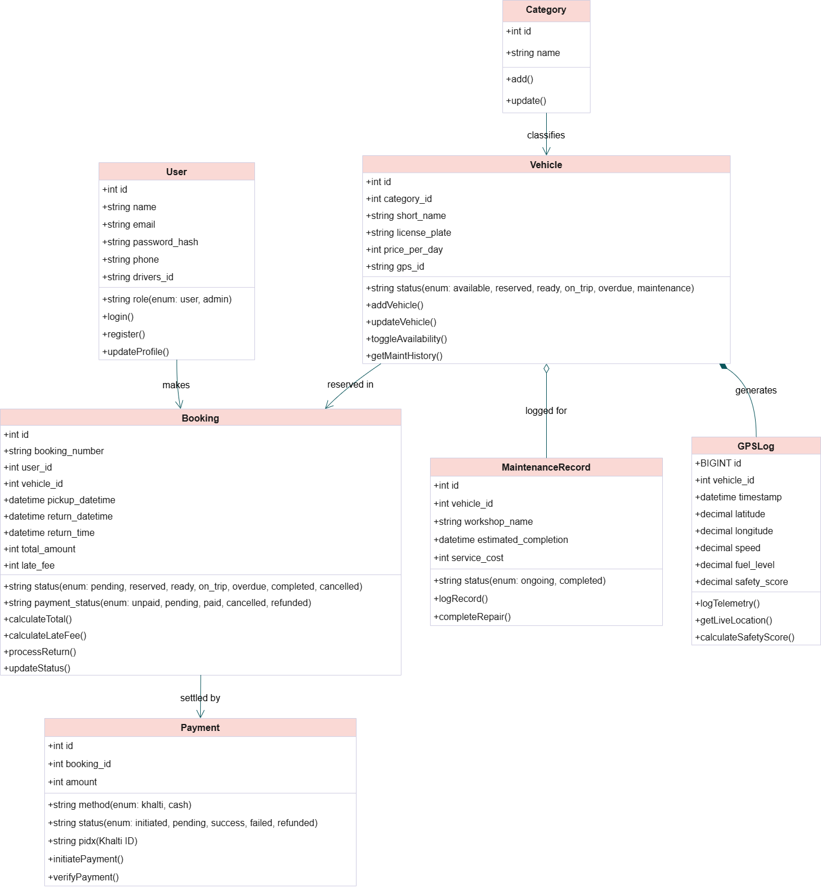

Fig 7: Class Diagram

Sequence Diagram
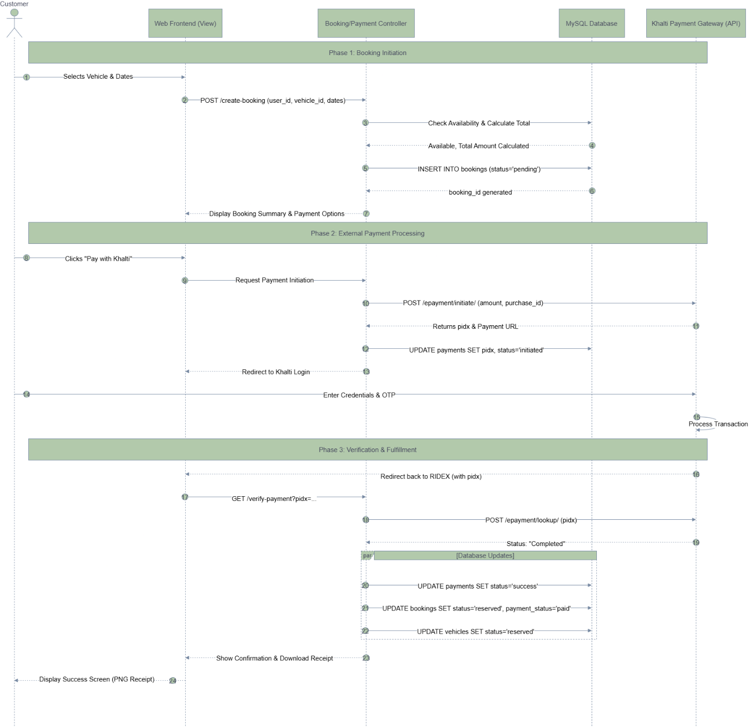

Fig 8: Sequence Diagram

